Super Single Wheel Option for M35A2- 2.5 Ton 6x6 or Bobbed 4x4
Option 1:
We carry a custom wheel that is 20x11 Modular Spoke Wheel, 6 on 8 ¾ Lug Pattern. These wheels have a negative offset with a 6” backspace. The reason we built these wheels was to give the tire an aggressive stance underneath the truck. They aren’t sucked in under the fender. (*Majority of all Military wheels have a positive offset which moves the tire more under the fender and closer to the chassis*)
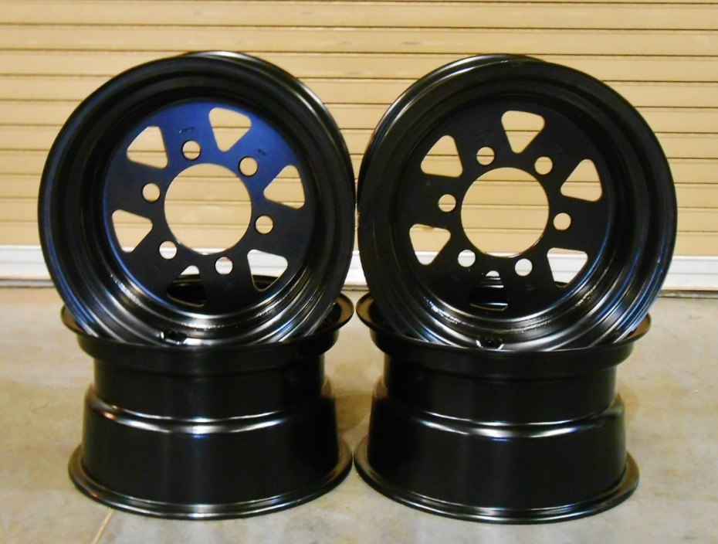
The other reason we built these wheels was to fit our Power Steering Kit. The steering box is mounted on the outside of the chassis. To run a bigger tire like a 395/85R20 (46” Tall) we had to build this wheel so you can get a full turn radius without hitting the steering box.
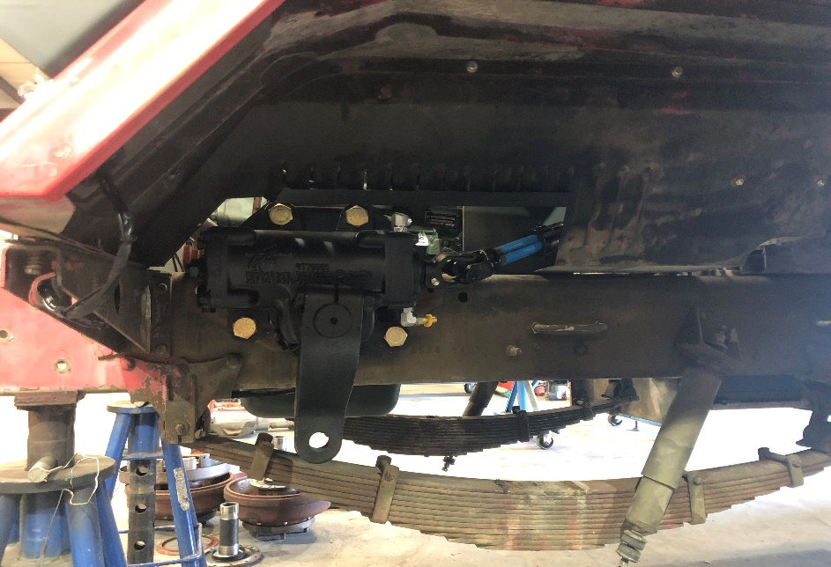

*We have used these wheels on the 14.00R20 (49”) w/no power steering and we have installed 16.00R20 Tire (53”) w/power steering and an 8” lift Kit (Pictured below)
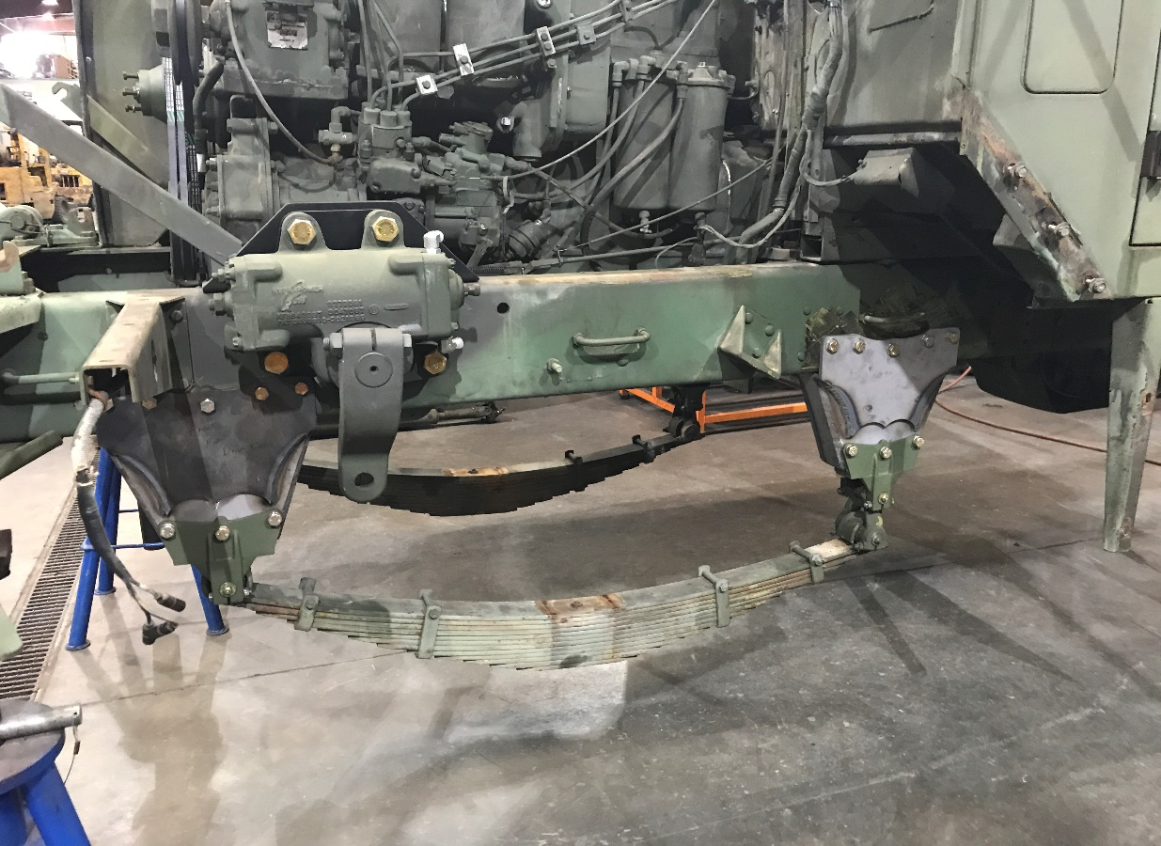
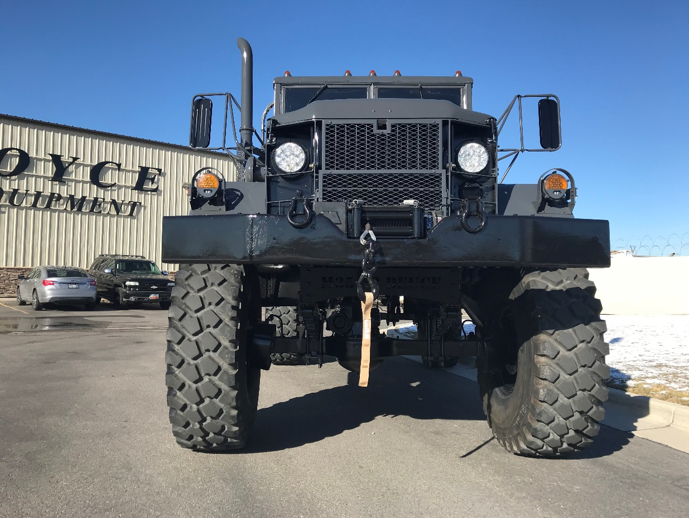
Option 2:
In the mid 80’s the military took the M35A2 truck and changed up the engine/transmission and a couple other things to make the M35A3. This truck came stock with the super single 14.5R20 Tires (44” Tall) w/ a Military Bead Lock 6 lug style wheel. This wheel option is a great option, but this wheel option will not work with our Power Steering Kit. Again, this wheel has a positive offset. Any guy that has a 6x6 or a 4x4 with the stock steering, this would be a great option.
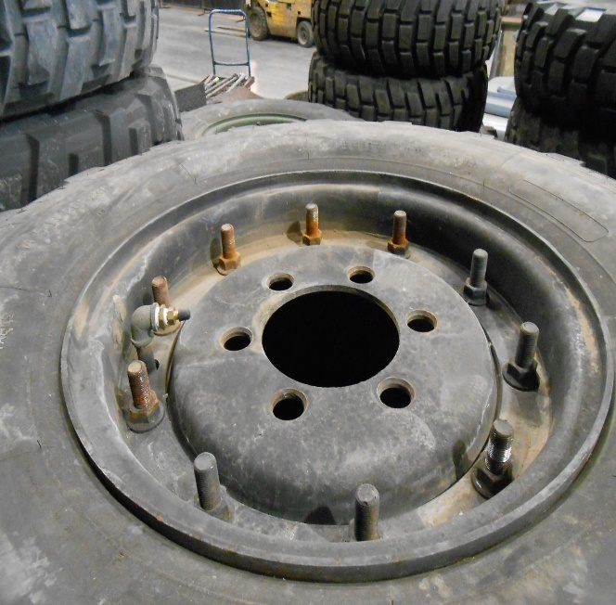
Option 3:
The other option that guys are doing is using the MRAP wheel. The MRAP wheel is a 20x10 Aluminum or Steel Wheel that is 10 lug. Guys will run a 6-lug adaptor to this wheel to run on the 2.5 Rockwell axles under the truck. This wheel gives the combat wheel look that guys want on their trucks. Again, this wheel has a positive offset and will not work with our Power Steering Kit. You will also need hardware to bolt the adapter to the wheel.
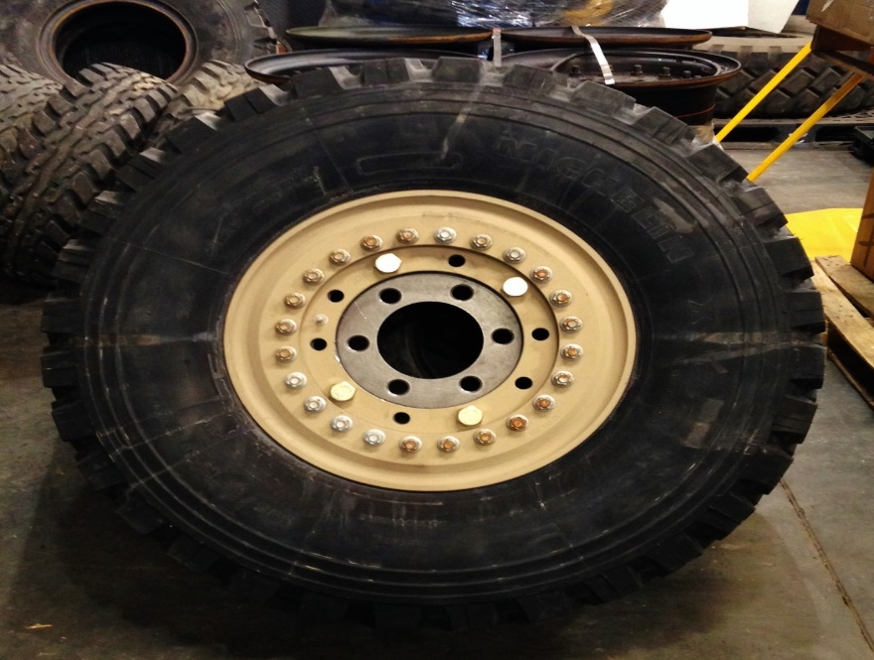
*Picture listed below is the stock M35A2 Split Rim that guys are getting away from. We have seen these wheels installed on a bigger, wider, tubeless tire before. We would not recommend this, but there are some guys that are out there that go with this option to save money. These wheels also will not work with our Power Steering Kit*
The stock military split rim runs tubes and flaps and fit the 9x20, 11x20, and 12x20 Tires. A lot of your super singles tires (14.5R20, 395/85R20, 14.00R20, 16.00R20 for example) with bead lock wheels do not run a tube or flap. They will either run a bead lock or a combo run flat w/ bead lock.
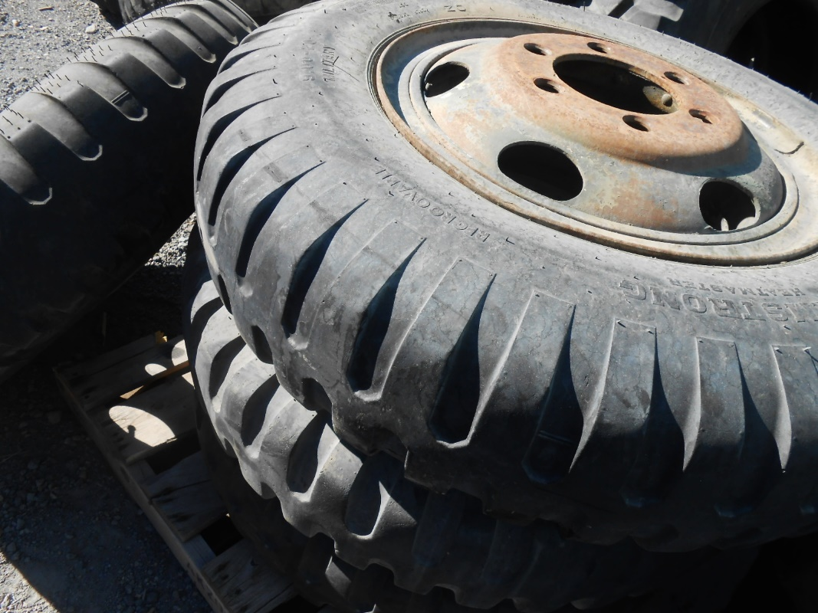
*Our Boyce Power Steering Kit will only work with our Custom Wheel, listed in Option 1*

